Diagnostic Modes
Diagnostic Connector Identification
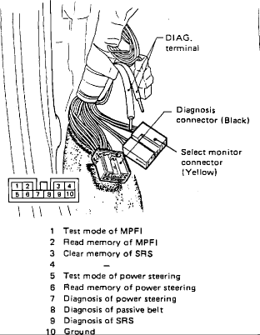
PURPOSE
The self-diagnosis system detects, stores and has provision for reading codes indicating various faults with electronic engine and emission controls. A "CHECK ENGINE" light on the instrument panel indicates the presence of trouble codes and the actual codes. The system has a fail-safe function which will default to a preset value when a part is judged defective, thereby maintaining minimal driveability until repairs can be made.
LOCATION AND ID
- CHECK ENGINE LAMP On the instrument cluster.
- DIAGNOSTIC CONNECTOR 10 pin connector in the left kick panel.
- DIAGNOSTIC TERMINALS Two (2) mini-spade connectors in the left kick panel.

Trouble Code
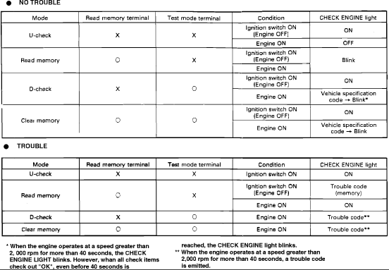
OPERATION
For accessing codes, two connectors (Diagnosis connector and Diagnostic terminal) and a "CHECK ENGINE" light are used. The connectors are for mode selection and the lamp monitors the type of problem. The Diagnostic connector is a ten (10) pin black connector and the diagnostic terminal is two (2) mini spade connectors. Both connectors are located in the left side kick panel.
The self-diagnosis system has four modes:
- U-Check Mode: Only components necessary for proper starting and drive operation are monitored. The "CHECK ENGINE" light will come on when a fault is detected, indicating the need for further diagnosis. Parts which do not significantly affect starting or driveability are not monitored in this mode.
- Read Memory Mode: This mode is used to read codes of past problems stored in memory and can be accessed when the "CHECK ENGINE" light is off. It is effective for detecting poor contact or loose electrical connections.
- D-Check Mode: This mode checks the entire system and displays any trouble codes currently being monitored.
- Clear Memory Mode: This mode removes trouble codes from memory after repairs are made.
Selecting Diagnostic Modes
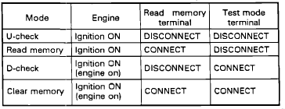
RELATIONSHIP BETWEEN MODES AND CONNECTORS
- U-CHECK MODE: Ignition "ON," Read Memory disconnected, Test Mode disconnected.
- READ MEMORY MODE: Ignition "ON," Read Memory connected, Test Mode disconnected.
- D-CHECK MODE: Ignition "ON," Read Memory disconnected, Test Mode connected.
- CLEAR MEMORY MODE: Ignition "ON" (engine on), Read Memory connected, Test Mode connected.
Reading Trouble Codes
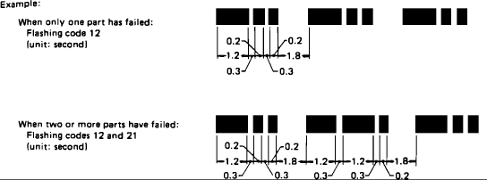
READING TROUBLE CODES
The "CHECK ENGINE" lamp flashes the code corresponding to the faulty part. The long segment (1.2 seconds "on") indicates a "ten" and the short segment (0.2 seconds "on") indicates a "one."

